press release
(English translation)

IBE - INTERMOBILITY AND BUS EXPO 2024 CONFIRMS ITS LEADERSHIP FOR THE FUTURE OF SHARED AND INTERCONNECTED MOBILITY

- Upsurge in exhibitors (+58%) and professional visitors doubled (+90%) compared to 2022 with a significant increase in the number of foreign visitors
- Featuring the first edition of Intermobility Future Ways, in collaboration with the Foundation for Sustainable Development and Euromobility

Rimini(Italy), 21 novembre 2024 – The eleventh edition of IBE Intermobiltity and Bus Expo, the reference event of Italian Exhibition Group (IEG) for the world of collective transport and related industrial supply chains, wrapped up today at Rimini Expo Centre.
Never has IBE recorded such record attendance with a sharp increase in professional visitors (+90%), compared to the 2022 edition, as well as in the number of exhibitors (+58%) and foreign companies present (+11%) over ​​31,560 square metres (+32%).
Ten buses carried out test drives and over 370 people took at least one test drive in the three days. The 40 conferences and workshops that filled the three days of IBE were very popular, with the participation of over 150 speakers.
The event also attracted great attention from the press, with 40% of journalists from abroad, confirming the increasingly international appeal of IBE.
The eleventh edition of IBE has established itself as a national reference ecosystem for the Bus and Coach supply chain increasingly oriented towards decarbonisation with innovative paths for interconnected, integrated and shared mobility.
The 2024 edition featured the debut of Intermobility Future Ways, the first National Forum on shared mobility, created in collaboration with the Foundation for Sustainable Development and with the technical support of the National Observatory of sharing mobility and Euromobility with the aim of connecting diverse and complementary worlds that work together to implement regulations, spread knowledge and best practices, promote new paths and provide new business models for sustainable and interconnected mobility.

Among the main exhibitors of the 11th edition: IVECO BUS, Irizar, Sitcar Mobility Vehicles, Scania, Volvo Buses and Otokar, MAN, Isuzu Bus Italia, King Long, Troiani, Gruppo D’Auria, INDCAR and many other internationally renowned players. Also present, the main partners of Intermobility future Ways: RFI, Trenitalia, Deloitte, Nordcom, Corrente (TPER group) and Lime.

During IBE 2024, the winners of the 1st edition of the Lorenzo Cagnoni Award for Innovation were announced, dedicated to Italian and international excellence in the field of sustainable innovation. Divided into two categories, the award acknowledged the most innovative projects of the exhibiting companies and start-ups present in the Innovation District, namely: RFI-Rete Ferroviaria Italiana, Sono Motors GmbH, ZF Italia, Wayla Srl, S.D.S. Safety Driving Solutions Srl and NCM.

IBE is organised in collaboration with AN.BTI Confcommercio and ASSTRA and with the backing of the Ministry of Infrastructure and Transport, the Ministry of the Environment and Energy Security, the Emilia Romagna Region, the Municipality of Rimini and the Province of Rimini, Cassa Depositi e Prestiti, the National Association of Italian Municipalities and the European Commission, ANGI (National Association of Young Innovators)
The next edition of IBE Intermobility and Bus Expo will be held from 24 to 26 November 2026, but in the meantime, a series of run-up events will be organised during 2025, dedicated to intermobility Future Ways and a new edition of IBE DRIVING EXPERIENCE.

PRESS CONTACTS - ITALIAN EXHIBITION GROUP
head of media & corporate communication: Elisabetta Vitali; press office manager: Marco Forcellini, Pier Francesco Bellini; international press office coordinator: Silvia Giorgi; press office coordinator: Luca Paganin; press office specialists: Nicoletta Evangelisti, Mirko Malgieri; media@iegexpo.it
Contatto per i Media
Twister communications group
Patrizia Vallecchi - pvallecchi@twistergroup.it – cell. 335 6334169
Monica Cipparrone - mcipparrone@twistergroup.it – cell.349 2814894
Valentina Tua – vtua@twistergroup.it – cell. 342 168 3535
Andrea Franceschi - afranceschi@twistergroup.it – cell. 335 7485194

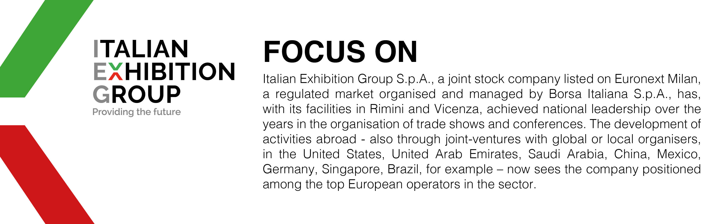

This press release contains forecast elements and estimates that reflect the management’s current opinions (“forward-looking statements”), particularly regarding future management performance, realization of investments, cash flow trends and the evolution of the financial structure. For their very nature, forward-looking statements have a component of risk and uncertainty, as they depend on the occurrence of future events. The effective results may differ (even significantly) from those announced, due to numerous factors, including, only by way of example: food service market and tourist flow trends in Italy, gold and jewellery market trends, green economy market trends; the evolution of raw material prices; general macroeconomic conditions; geopolitical factors and evolutions in the legislative framework. Moreover, the information contained in this release does not claim to be complete, and has not been verified by independent third parties. Forecasts, estimates and objectives contained herein are based on the information available to the Company as at the date of this release.

